**CG-Assignment**

**Polygon Clipping**

**Program:**

Writing a program to implement Sutherland Hodgeman Polygon Clipping algorithm

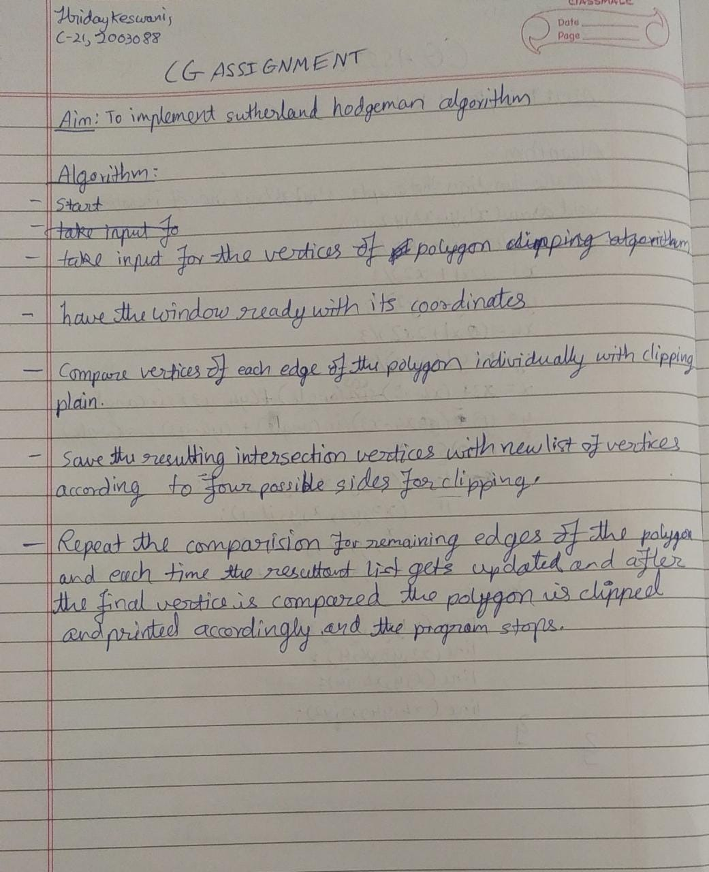

**Code:**

#include<stdio.h>

#include<graphics.h>

#include<conio.h>

#include<stdlib.h>

int main()

{

int gd,gm,n,*x,i,k=0;

//window coordinates

int w[]={220,140,420,140,420,340,220,340,220,140};//array for drawing window

detectgraph(&gd,&gm);

initgraph(&gd,&gm,"C:\\TURBOC3\\BGI"); //initializing graphics

printf("Window:-");

setcolor(RED); //red colored window

drawpoly(5,w); //window drawn

printf("Enter the no. of vertices of polygon: ");

scanf("%d",&n);

x = malloc(n*2+1);

printf("Enter the coordinates of points:\n");

k=0;

for(i=0;i<n*2;i+=2) //reading vertices of polygon

{

printf("(x%d,y%d): ",k,k);

scanf("%d,%d",&x[i],&x[i+1]);

k++;

}

x[n*2]=x[0]; //assigning the coordinates of first vertex to last additional vertex for drawpoly method.

x[n*2+1]=x[1];

setcolor(WHITE);

drawpoly(n+1,x);

printf("\nPress a button to clip a polygon..");

getch();

setcolor(RED);

drawpoly(5,w);

setfillstyle(SOLID_FILL,BLACK);

floodfill(2,2,RED);

gotoxy(1,1); //bringing cursor at starting position

printf("\nThis is the clipped polygon..");

printf("\n\nHriday Keswani\n2003088\nC-21");

getch();

cleardevice();

closegraph();

return 0;

}

**Output:**

